

MATLAB-EXPERIMENT 4B

TRIPLE INTEGRALS



march 26, 2021

BIMAL PARAJULI

20BDS0405

Department of Mathematics

School of Advanced Sciences

MAT 1011 – Calculus for Engineers (MATLAB)

Experiment 4-B

TRIPLE INTEGRALS

Prepared by: Bimal parajuli

Registration Number: 20BDS0405

**Question 1:**

**Find the volume of the region bounded between the planes x + y + 2z = 2 and 2x + 2y + z = 4 in the first octant.**

**CODES:**

close all;

clear;

clc;

% to find triple integral over a region

syms x y z;

%specifying the limit of integrals wrt x,y,z

lower_x = 0;

upper_x = 2;

lower_y = 0 + 0 * x;

upper_y = 2 - x;

lower_z = (2 - x - y)/2;

upper_z = 2*(2 - x - y);

%calculating the triple integral which gives the volume enclosed

volume = int(int(int(1 + 0*z, z, lower_z, upper_z), y, lower_y, upper_y),x, lower_x, upper_x);

%displaying the volume enclosed

disp("The volume bounded by x + y + 2z = 2, 2x + 2y + z = 2 and first octane is = ");

disp(volume);

%displaying the 3D plot

figure(1)

viewSolidone(z, lower_z, upper_z, y, lower_y, upper_y, x, lower_x, upper_x);

xlabel("X-axis");

ylabel("Y-axis");

zlabel("Z-axis");

**OUTPUT:**

The volume bounded by x + y + 2z = 2, 2x + 2y + z = 2 and first octane is =   
2

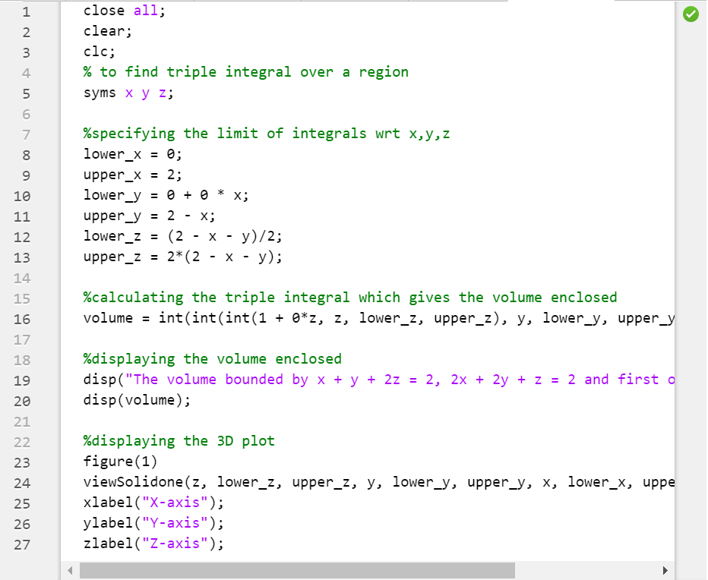

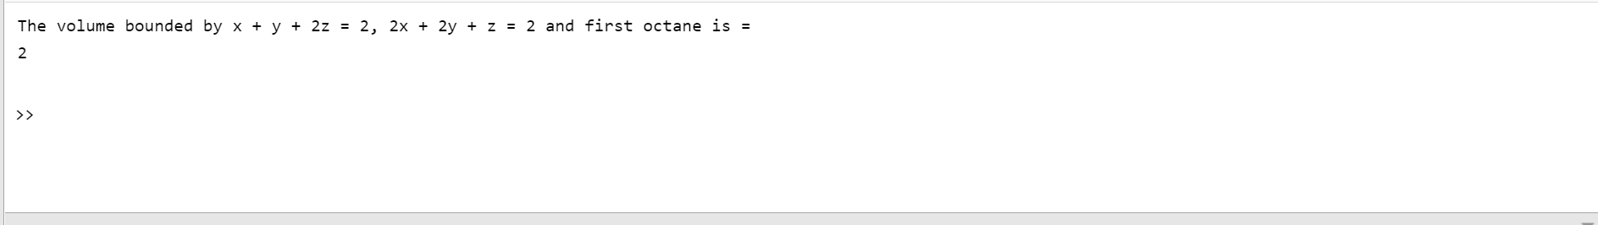

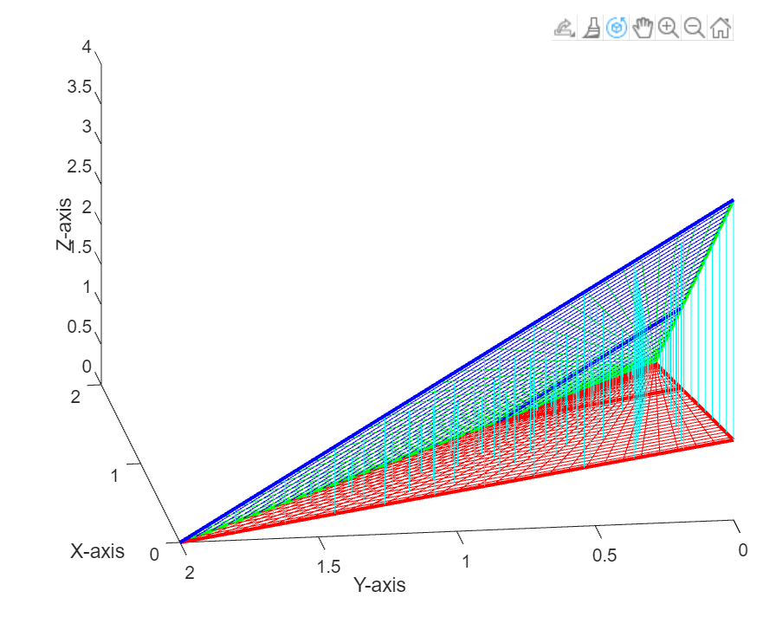

**Question 2:**

**Find the volume of the region cut from the solid elliptical cylinder x2 + 4y2 ≤ 4 by the xy − plane and the plane z = x + 2.**

**CODES:**

close all;

clear;

clc;

% to find triple integral over a region

syms x y z;

%specifying the limits of integrations

lower_x = -2;

upper_x = 2;

lower_y = - (sqrt(4 - x^2)/2);

upper_y = sqrt(4 - x^2)/2;

lower_z = 0 + 0*x ;

upper_z = x + 2;

%calculating the volume enclosed by triple integration

volume = int(int(int(1 + 0*z, z, lower_z, upper_z), y, lower_y, upper_y), x, lower_x, upper_x);

%displaying the volume

disp("The volume bounded by x^2 + 4y^2 <= 4, z = 0 and z = x + 2 is = ");

disp(volume);

%displaying the 3D-Plot of the planes

figure(1)

viewSolidone(z, lower_z, upper_z, y, lower_y, upper_y, x, lower_x, upper_x);

xlabel("X-axis");

ylabel("Y-axis");

zlabel("Z-axis");

**OUTPUT:**

The volume bounded by x + y + 2z = 2, 2x + 2y + z = 2 and first octane is =   
2

>>

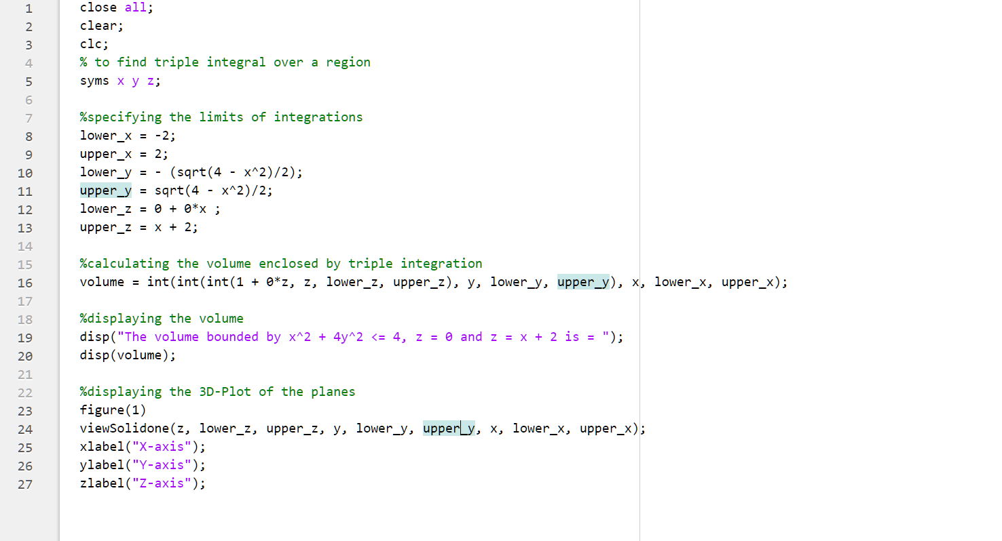

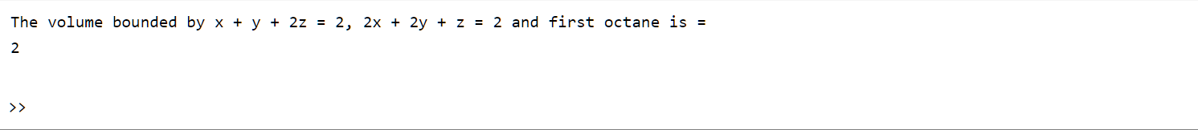

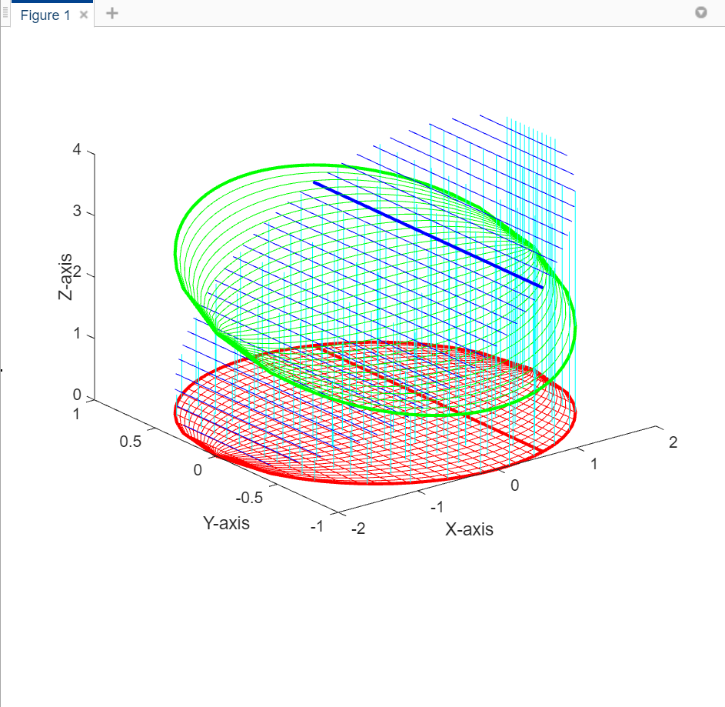

**Question 3:**

**Calculate the finite region bounded by the planes z = x , x + z = 8, z = y , y = 8 and z = 0.**

**CODES:**

close all;

clear;

clc;

% to find triple integral over a region

syms x y z;

%specifying the limits of the integrals

lowerx = z; upperx = 8 - z;

lowery = z ; uppery = 8 + 0*z;

lowerz = 0 ; upperz = 4;

%calculating and displaying the volume enclosed

volume = int(int(int(1 + 0*x, x, lowerx, upperx), y, lowery, uppery), z, lowerz, upperz);

disp("The volume bounded by z = x , x + z = 8, z = y , y = 8 and z = 0 is = ");

disp(volume);

%visualizing the 3D plot of the planes

figure(1)

viewSolidone(x, lowerx, upperx, y, lowery, uppery, z,lowerz, upperz);

xlabel("X-axis");

ylabel("Y-axis");

zlabel("Z-axis");

**OUTPUT:**

The volume bounded by z = x , x + z = 8, z = y , y = 8 and z = 0 is =   
320/3

